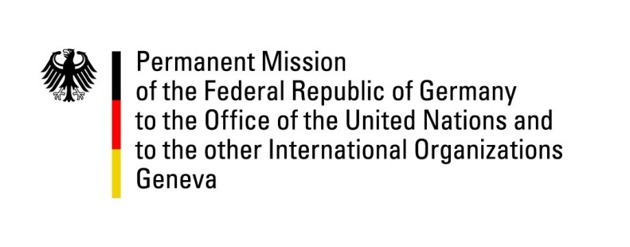

United Nations Human Rights Council
24th Session of the UPR Working Group

Geneva, 19th January 2016
---
German recommendations and
questions submitted in advance to
Estonia

Mr. President,

Germany warmly welcomes the delegation of Estonia to the UPR and commends the government for the significant progress achieved since the 1st cycle.
While some challenges persist, we particularly welcome that since the last UPR,
the Estonian government has taken a number of steps to implement some of the
reforms to which it committed itself during the Human Rights Council’s review of
Estonia under the UPR procedure in 2011. These include, for example, ratifying the Convention on the Rights of Persons with Disabilities (CRPD) and its Optional Protocol (OP). Estonia also ratified the Optional Protocol to the Convention on the Rights of the Child on the involvement of children in armed conflict (OP-CRC-AC).

However, we see some persisting shortcomings in the field of non-discrimination in particular of minorities.

In this regard, we wish to make the following recommendations:
- To pursue 'hate speech'-offenses more vigorously by not only condemning violations but to investigate, prosecute and punish violators in a consistent manner.

- To launch a debate on issues concerning ethnic and cultural diversity aiming at promoting tolerance towards divergent cultural, religious and sexual orientations within the Estonian society.

- To establish a body (ombudsman, commissioner or the like) as a prominent institution to protect the rights of minorities and immigrants.

Questions submitted in advance:

- Germany would like to learn more on how the government of Estonia intends to strengthen the paragraphs in the Penal Code which aim to deal with crimes motivated by racism.
- According to recent reports, ethnic minorities continued to be disproportionately affected by unemployment and poverty, leading to concerns that ethnic and linguistic discrimination could be a contributing factor. Language requirements for employment were reportedly placing ethnic minorities at a disadvantage. What measures is the government of Estonia taking to secure further equality in this respect?

